Lab 7 Report

Kiran Nadkarni

Elizabeth

10/17/19

1- 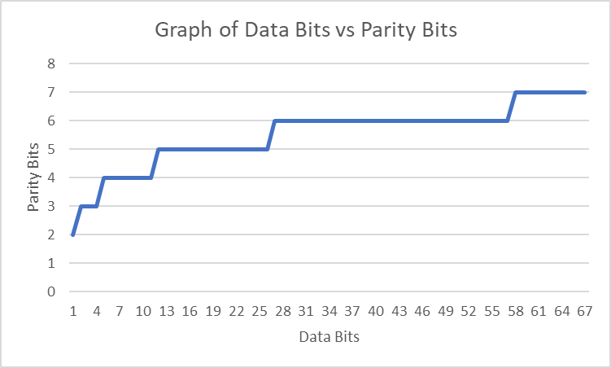

2- we would need an 8th bit to check for a second error, so a 4th check bit. This would add a fourth XOR gate in the parity generator to generate P4, and since we cannot correct the error it would not add anything to the error corrector.

3- The Hamming Distance is essentially the number of changes you would have to make to turn one binary string into another. For instance. The Hamming Distance between 0110 and 0000 is 2, because you would have to change two 1s into 0s.